TCP STREAMING

# AIM: TO Analysis of TCP streaming with filtering

# REQUIREMENT

switch

server,

pc’s,

cable to connect the devices

# PROCEDURE:

The following instructions are based on the Configuring TCP/IP function of Windows XP.

1. Click **Start** > **Settings** > **Control Panel**.
2. On the control panel, double-click **Network and Dial-Up Connections**.
3. Right-click **Local Area Connection**.
4. Click **Properties**. If **Internet Protocol (TCP/IP)** does not appear in the list, do the following:
   1. Click **Install**.
   2. Select **Protocol**, and then click **Add**.
   3. Select **Internet Protocol (TCP/IP)**.
   4. Click **OK**. This returns you to the Local Area Connection Properties window.
5. Select **Internet Protocol (TCP/IP)**, and then click on **Properties**.
6. Select **Using the Following IP Address**. Check with your network administrator to determine the correct settings for this tab. If your PC does not automatically obtain IP and DNS addresses, do the following:
   1. Enter the IP address of your PC (for example, 199.5.83.205).
   2. Enter the subnet mask (for example, 255.255.255.0).
   3. Enter the default gateway (for example, 199.5.83.1).
   4. Enter the preferred DNS server (for example, 199.5.100.75).
   5. Enter the alternate DNS server (for example, 199.5.100.76).
7. If you are using a Windows Internet Name Server, click the **Advanced**tab, select **WINS Address**, and do the following:
   1. Click **Add**.
   2. Enter the primary WINS server (for example, 199.5.83.205).
   3. Enter the secondary WINS server (for example, 199.5.83.206).
   4. The remaining settings should remain as the defaults.
8. Click **OK** on the **Local Area Connection Properties**window. It is not necessary to restart your PC.

# IMPLEMENTATION:

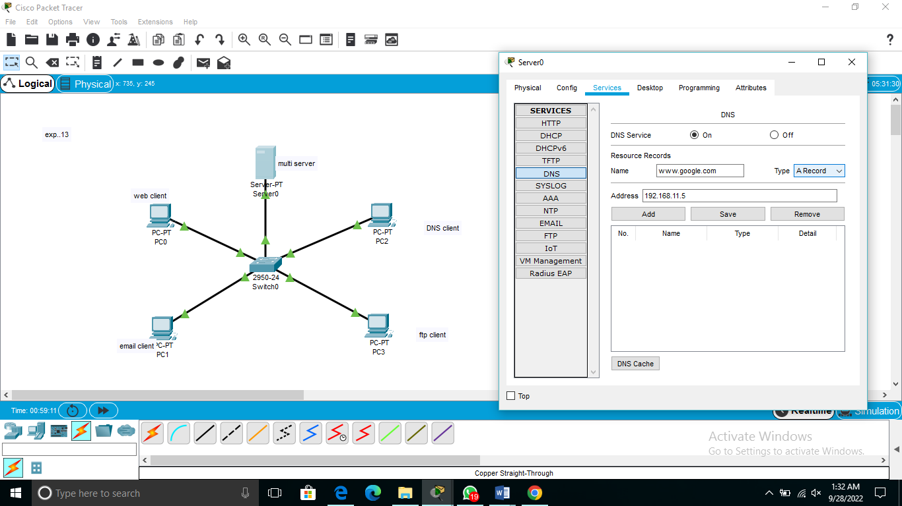

.

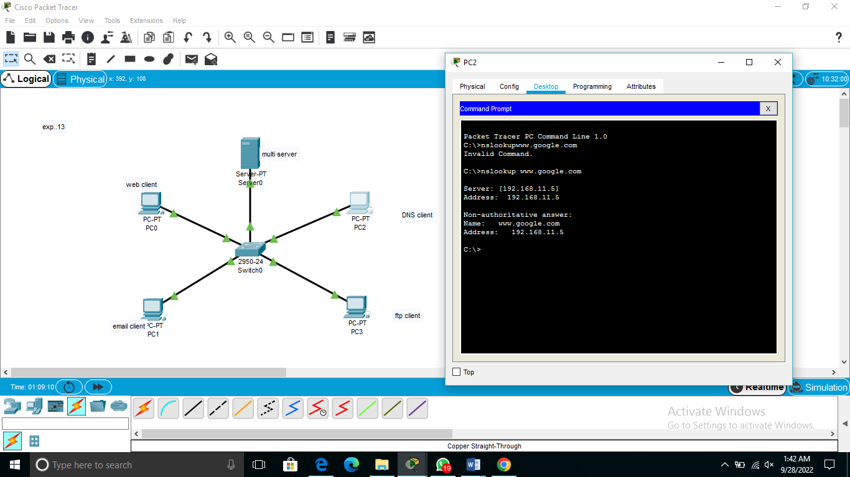

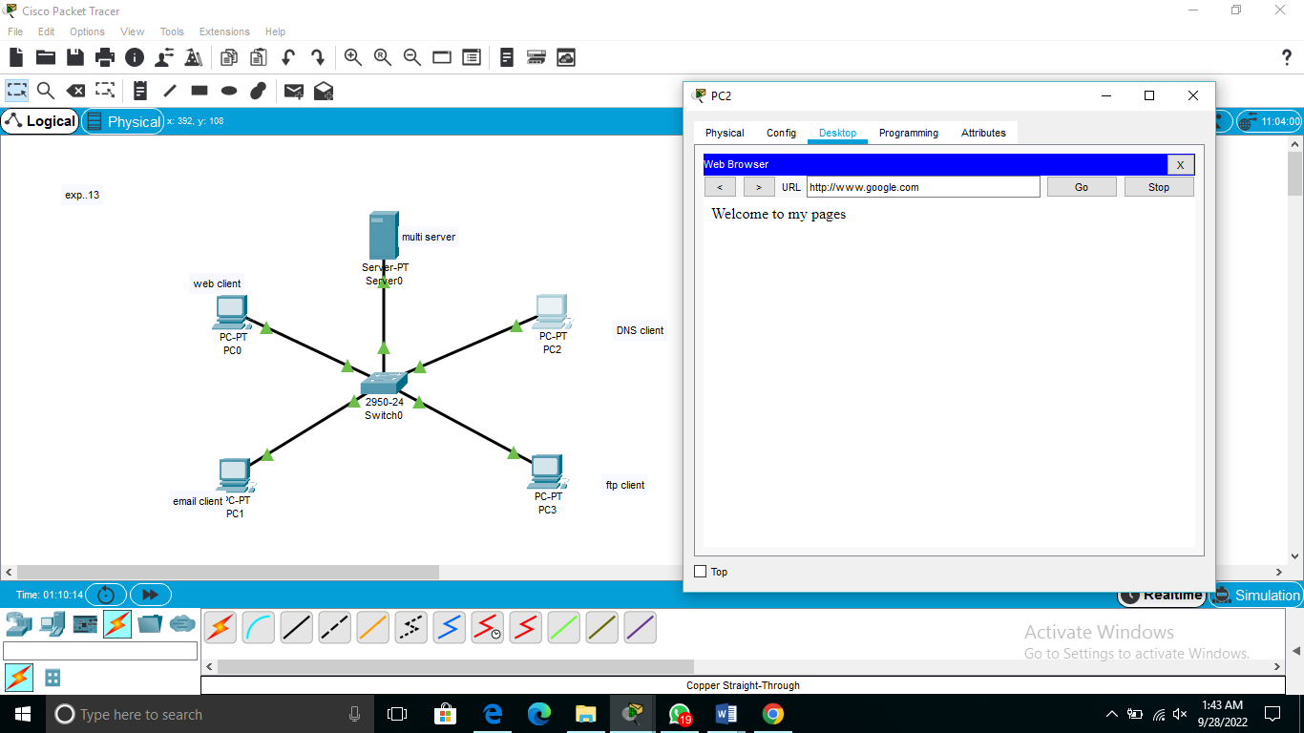

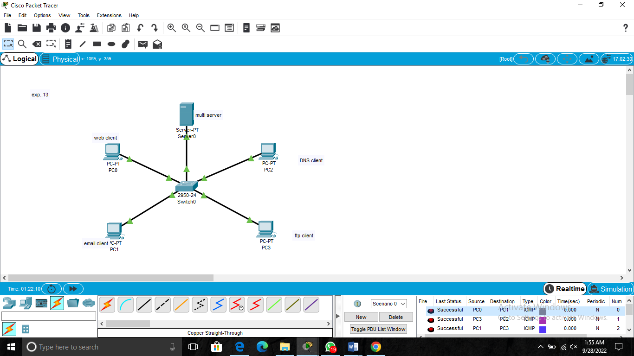

# RESULT:

Thus the Local streaming of tcp was established and the communication

among the machines using ping command is verified successfully